**Scenario: Fight the Fire**

A block of high-rise flats in Bristol is on fire. The fire brigade are able to fight the fire on the lower floors but aren’t able to extinguish the flames on the upper floors. The fire brigade have deployed their new drone to collect water and put out the fire from above.

***We want you to design the best drone for the job by adding some bio-inspired upgrades!***

Allowances

Weight allowance 105 kg (100 kg of water)

Power allowance 60 W

Money allowance £400

Things to think about:

* You need to make as many trips as possible to extinguish the fire
* You need to be as fast as possible to save the building!
* Power not used by the upgrades can be used to fly the drone faster
* Be accurate when delivering the water!
* Do not exceed your money budget

Fill in the table below with your sensor combinations and circle the final choice

|  |  |  |  |
| --- | --- | --- | --- |
| Upgrades | Weight (Kg) | Power (W) | Cost (£) |
| *Example* GPS, IMU, Gripper | 0.5 + 0.5 + 1 = 2 | 5 + 5 + 15 = 25 | 50 + 50 + 100 = 200 |
|  |  |  |  |
|  |  |  |  |
|  |  |  |  |
|  |  |  |  |
|  |  |  |  |
|  |  |  |  |

Game instructions:

*Fly the drone to the river to collect water, then fly to the building and flip the drone to expel the water and extinguish the fire.*

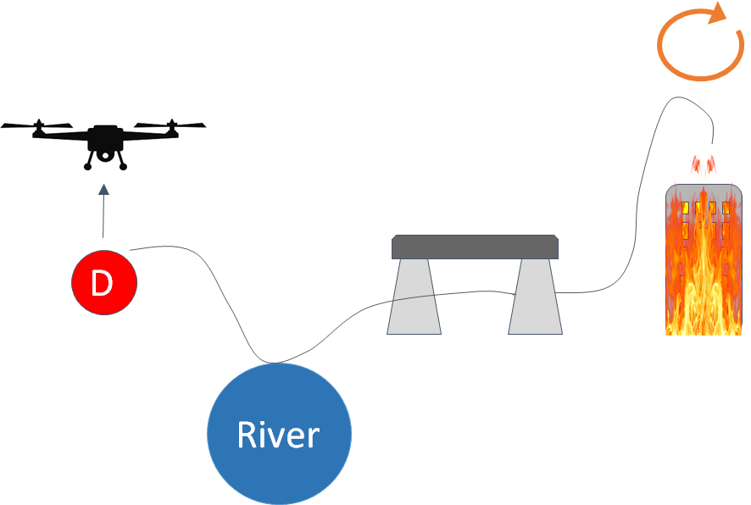

*To flip: Push the button on the RHS of the controller then push the RHS joystick in the direction you want to flip*